Greetings from The Amazing Chemistry Show!

I hope you are as excited as I am about the upcoming Amazing Chemistry Show. I can’t wait to see how this event will be used to serve your church and your community.

Here you will find a variety of promotional materials to help you plan for and communicate about the event, publicize this to your community and encourage people to attend. Materials include:

- Event Preparation Tips
Follow these tips and best practices for planning for your event.

- Press Release
Send the press release to local media to let them know about The Amazing Chemistry Show and try to get media coverage for the event.

- Pitch Email
Use this email to more informally contact local media and suggest they cover the event as a news story, with an offer for an interview.

- Photo Captions
Use these captions along with any of the photos provided on this site to help promote the event. These can be shared with media if photography is requested.

- Online Calendar of Events Listing
Publicize The Amazing Chemistry Show on other online calendars using this event description.

- Recommended Tweets/Facebook Status Updates
Update your social media accounts in the weeks leading up to The Amazing Chemistry Show. Use these short posts to get people excited about the event.

- Blog Post
Update your church’s blog to promote the event and give people more information about The Amazing Chemistry Show.

- Testimonials
Share these with media, if requested, or use in any of your print communications.

These materials were prepared to promote The Amazing Chemistry Show. When using these materials, please read and edit them carefully to include all the important details related to your specific event. If you are hosting The Amazing Chemistry Show in conjunction with another program or outreach event, you may need to do further editing to encompass all aspects of your event. I look forward to serving alongside you soon!
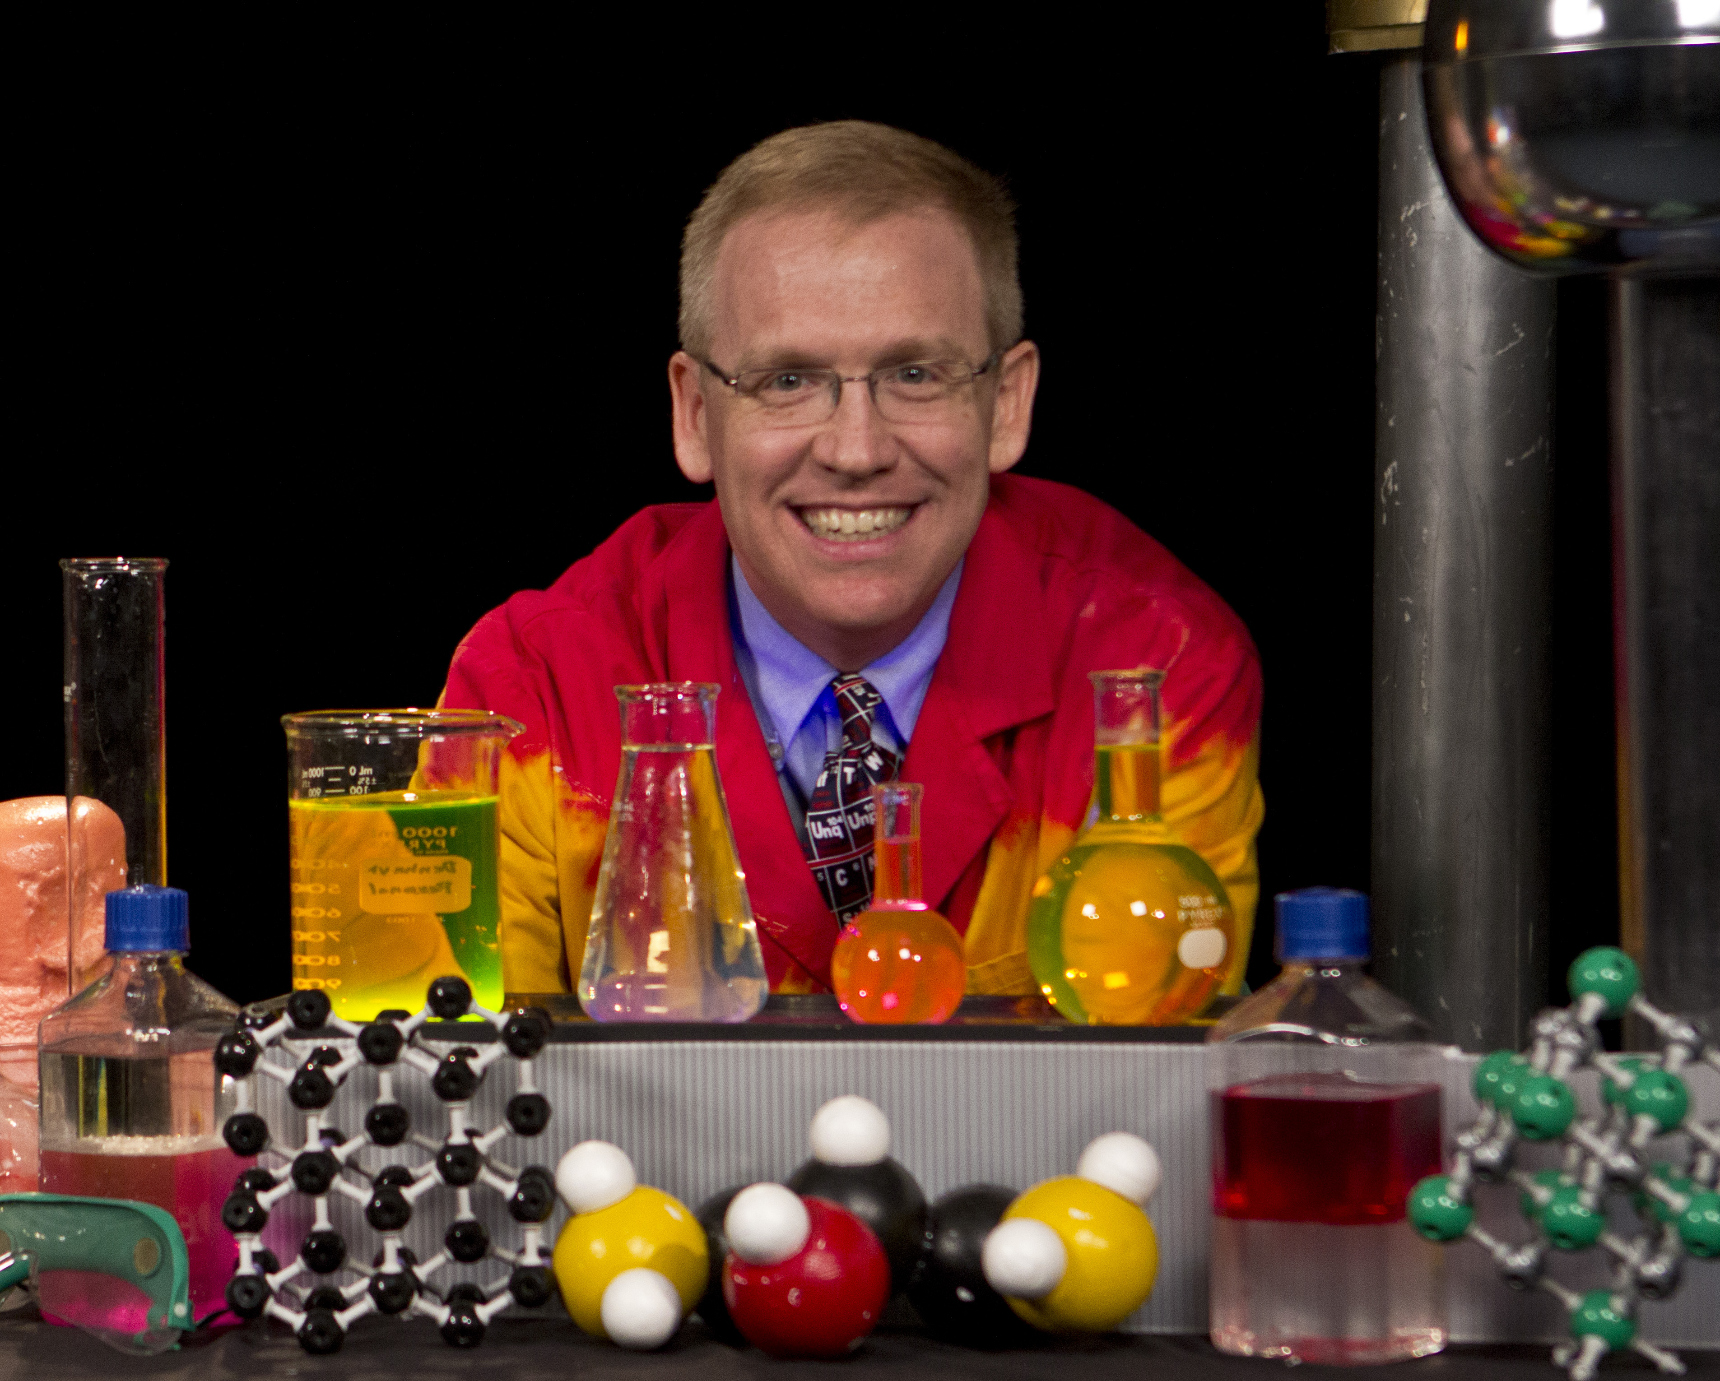
Josh Denhart

#1 - EVENT PREPARATION TIPS

Ready! (several months in advance)

What’s the Point?
Likely you have already considered and answered these questions: Who is our main audience? What is the goal of the event? When is the best time to hold this event? Why is this event worth the time, energy and resources required? Refer back to these foundational questions to guide all your planning and execution.

Consider the Calendar
You’ve already selected the date for The Amazing Chemistry Show. Double check that it is included on all critical calendar systems and that key leaders and volunteers have this date set aside.

Promote the Event
Use the materials provided on this site to promote The Amazing Chemistry Show. Update your Web site and add a blog entry, if applicable. Use material provided for newsletters or group emails. Put event teasers on your Twitter and Facebook accounts. Contact local media and post the event on community calendars. Consider print materials or other communication you will be distributing at this time – are there any ways to cross-promote or further advertise The Amazing Chemistry Show through communications you are already doing?

Consider Specific Individual for Specific Job Descriptions
Create a timeline of action-oriented tasks to be accomplished at various checkpoints.

- Rocket Building – 2-4 weeks prior to the show, gather a groups of 5-8 volunteers who will spend 2 hours building/constructing card stock paper rockets. Volunteers will watch the tutorial video (if needed) and build 50-75 rockets of the various designs I have provided.
- Event Coordinator – This volunteer or staff person will ensure all details have been covered, including recruiting, trouble shooting, promotion, etc.
- Station Set Up – When Josh arrives, 6 able bodies volunteers will be available to lift and carry all the items needed for each science station. In addition, these volunteers will unpack and set out all the specific items on individual tables according to the diagrams provided (see Family Experience Volunteer Instructions Documents). Volunteers should be available at least1.5 hours for full set up.
- Station Volunteers – These 25 volunteers will arrive 30-45 minutes prior to event kick-off and will be present as families arrive at the event. They will be assigned to specific stations (example: Magnet Mania) and will be responsible a section of demonstrations/experiences at their station (example: a volunteer may be responsible for 4 of 25 magnet experiences). They are to interact, invite and instruct families as to how to experience the segment of experiences they are overseeing. Event coordinator will provide these volunteers with the specific “Family Experience Volunteer Instruction” sheet that applies to where they will be serving. Josh will personally provide brief training for each volunteer about their specific area prior to families arriving.
- Station Tear Down – When the experience is over, 6 able bodies volunteers will be available to repack all the science items into the specific labeled tubs. In addition, these volunteers will lift and carry all the supplies and tubs and reload them on the enclosed trailer.

Invite Other Leaders
Job descriptions make it easy to invite leaders to oversee a particular aspect of The Amazing Chemistry Show. When being recruited, everyone appreciates knowing what is expected of them prior to helping.

Trust and Verify
Over the final weeks, meet weekly with leaders to see if they need your support. Pray about the details under their care and about those who will attend The Amazing Chemistry Show. Remind your leaders “why” you are tackling this event, and reinforce the important role they play. Whether on the phone or in person, this “check-in” is as much about inspiration as it is motivation.

Set! (one week in advance)

Final Check-in with Leaders
Schedule one last face-to-face meeting with your leaders, lending support, encouragement, vision, thanksgiving and prayer. Consider anything that might have been overlooked or any last-minute details that need attention.

Arranging Your Facility
Make sure that the room you’ll be using as well as tables/chairs/etc. will be ready for set up the day of the event, or begin your set up earlier in the week. Have volunteers lined up to help get the facility set up. Be sure to set up the facility according to the downloadable map you have been provided, placing black table coverings (cloth or plastic) over each table so they are completed as I arrive for set up.

Go! (guests have arrived)

First Impressions
The doors fly open and in walk those you have labored to serve. What will their first interactions with your church be like? Negative attitudes are unmistakable and impossible to hide. Paul the apostle admonishes us in Colossians 4:5-6, “Walk in wisdom toward outsiders, making the best use of the time. Let your speech always be gracious, seasoned with salt, so that you may know how you ought to answer each person.”

The “Yes” Face
Coach your volunteers to wear their "Yes” faces — ready and willing to answer questions, provide assistance and serve. If you and your volunteers are enjoying The Amazing Chemistry show — and you should be! — it will show.

Ministry is a People Business
People can be messy, loud and rude. Events like The Amazing Chemistry Show are designed for people; events are not for us to fine-tune our craft of event planning. Jesus said, “Those who are well have no need of a physician, but those who are sick...for I came not to call the righteous, but sinners.” Handle guests like royalty.

#2 – PRESS RELEASE
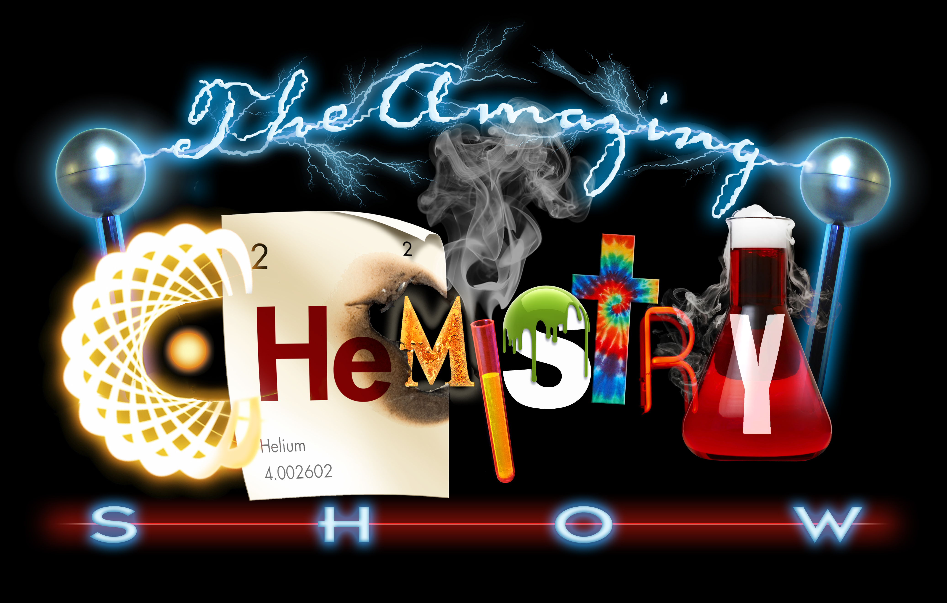
Contact: (INSERT NAME)
(INSERT PHONE NUMBER)
(INSERT EMAIL ADDRESS)

Families Invited to The Amazing Chemistry Show (INSERT DATE)

(INSERT CITY, STATE) (INSERT DATE OF RELEASE) — Families will be amazed and entertained by explosions, colored foam, liquid nitrogen and glow-in-the-dark solutions during The Amazing Chemistry Show on (INSERT DATE).

Founded by Josh Denhart, The Amazing Chemistry Show (www.theamazingchemistryshow.com) is an educationally entertaining stage production
using fast-paced and engaging science experiments to captivate kids and adults while sharing about the love God has for them.

(HOST VENUE) will host this free event at (INSERT TIME) on (INSERT DATE).

(IF HOSTING THE FAMILY EXPERIENCE IN CONJUNCTION WITH THE AMAZING CHEMISTRY SHOW, INCLUDE THIS PARAGRAPH. OTHERWISE OMIT.)
In addition to this hour-long production, families are invited to participate in a hands-on science experience with more than 150 exhibits featuring rockets, magnets, electricity, magnification, slime and more. The Family Experience will be held from (INSERT TIMEFRAME).

(INSERT HOST LOCATION) is located at (INSERT STREET ADDRESS).

Visit (INSERT WEB ADDRESS WHERE EVENT IS LISTED) or www.theamazingchemistryshow.com for more information.

###

#3 - PITCH EMAIL
Reach out to local media with a personalized email letting them know about The Amazing Chemistry Show and offering an interview. Use any personal connections you or anyone on your team has with local media to contact a reporter who might be willing to cover the event. If no personal connections, search media outlet Web sites for a news director, editor or reporter to contact. Revise the pitch email to include details as pertaining to your event.

(NAME OF CONTACT)

Have you ever had a large ball of fire safely ignited from your hand? Or used a banana to pound a nail into a wooden plank? Or been slimed by a puking plastic pumpkin? Families attending The Amazing Chemistry Show will be entertained by these experiments and more.

(HOST VENUE) will be hosting The Amazing Chemistry Show at (TIME) on (DATE). Kids and adults will be entertained by explosions, colored foam, liquid nitrogen and glow-in-the-dark solutions.

(IF CONTACTING CHRISTIAN MEDIA OUTLET, INCLUDE THE FOLLOWING PARAGRAPH. OTHERWISE OMIT.)
The chemical reactions, loud noises and unexpected twists will capture their attention while they hear the gospel being presented in a unique and stirring way.

Josh Denhart, founder of The Amazing Chemistry Show (www.theamazingchemistryshow.com), is available for phone interviews to share more about the science production and his heart for reaching kids and families. If you are interested, please contact me to arrange an interview time.

Regards,
(YOUR NAME)
(PHONE AND EMAIL CONTACT)

#4 - Photo Captions
Below are captions to use with The Amazing Chemistry Show event promotional photos. Choose a caption that is appropriate for the photo, and edit as needed. You can share these with media as requested, or use in your own electronic or print communications. Pictures will be available on your download site.

Fire, foam and fun! Come to The Amazing Chemistry show at (HOST VENUE) on (DATE) at (TIME) to see a unique, science-based stage production for the whole family.

The Amazing Chemistry Sow will be held at (HOST VENUE) on (DATE) at (TIME). This entertaining stage production filled with explosions, colored foam, liquid nitrogen and glow-in-the-dark solutions is free and open to families in the community.

Experience an explosive (AFTERNOON/NIGHT) of family fun at The Amazing Chemistry Show, to be held at (HOST VENUE) on (DATE) at (TIME). This upbeat stage production includes engaging science experiments and a gospel message presented in a unique way.
#5 - Online Calendar of Events Listing
Use the copy below to promote your event on free, local community calendars. Find online calendars by searching for community calendars, local kid event/activity calendars, mommy and me groups, Christian radio station calendars, local newspapers and print media calendars, other local media outlets, etc.

Experience an explosive (AFTERNOON/NIGHT) of family fun at The Amazing Chemistry Show, to be held at (NAME OF VENUE) on (DATE) at (TIME). Kids and adults alike will enjoy this entertaining production filled with fireballs, colored foam, liquid nitrogen, and glow-in-the-dark solutions. (NAME OF VENUE) is located at (ADDRESS). For more information, visit (INSERT WEB ADDRESS WHERE YOUR EVENT IS LISTED) and www.theamazingchemistryshow.
#6 - Recommended Tweets/Facebook Status Updates
In the weeks leading up to the event, update your Twitter and/or Facebook accounts with teasers to promote The Amazing Chemistry Show. A key component of getting your event noticed on Facebook is through “shares.” Encourage people to help promote the event by sharing your posts. You could also use these teasers in announcements and other print materials to promote the event. Edit the copy or write additional teasers as fitting for your event.

Super Slime! Magnet Mania! Ready, Set, Rockets! Mark your calendars now for The Amazing Chemistry Show to be held at (LOCATION) on (DATE) at (TIME). This will be an entertaining and educational family event that you will want to invite your friends and neighbors to! (link to 30 Second Promo video)

Gravity, elasticity, polymers … and Jesus? Come to the interactive, family-friendly Amazing Chemistry Show to learn about science and the love of Christ. (DATE), at (TIME) at (LOCATION). Bring a friend! (link to 3 minute promotional video)

It’s not for the faint of heart! Join us for The Amazing Chemistry Show at (LOCATION) on (DATE) at (TIME). (include promotional photo of Josh with fireball)

This isn’t what your high school chemistry class looked like? Adults and kids will have a blast learning about science and the love of Christ through interactive experiments and an engaging stage production. Come to The Amazing Chemistry show at (LOCATION) on (DATE) at (TIME). (include promotional photo of Josh with goggles and colorful beakers or Josh stuffing colorful balloons into tub)

If you are looking for an “explosive” way to “connect” with your family and “magnify” the love of Christ for your friends and neighbors, then join us for The Amazing Chemistry Show at (LOCATION) on (DATE) at (TIME). You won’t want to miss out! (include promotional photo of Josh with beaker on head)

Blast off! The Amazing Chemistry Show is here! Bring your family, friends and neighbors to see an explosive performance TODAY at (TIME) at (LOCATION). (link to Science VBS rocket cartoon)

YouTube Links to imbed:

- Promo Videos:
  - Family Experience Promo 120 second video - https://www.youtube.com/watch?v=xmAFkfGQ24Q
  - Family Experience 90 second video - https://www.youtube.com/watch?v=tCzAvRFMGTo
  - Family Experience 60 second Video - https://www.youtube.com/watch?v=PX-312RHfB0
  - Chemistry Show Promo Interviews 90 second spot - https://www.youtube.com/watch?v=k947XnaQH1I
  - 30 second Stage Show Promo - https://www.youtube.com/watch?v=VZAahd21JmQ
  - 3 min and 15 second Chemistry Promo video - https://www.youtube.com/watch?v=Y2MRlxJ450g
  - 38 second picture slide show of FIRE and EXPLOSIONS - https://www.youtube.com/watch?v=HgOpN_FTXIg
  - 34 second picture slide show of kid interactions and more! - https://www.youtube.com/watch?v=NK2jmmjcaYg

- Cartoons:
  - “Ready, Set, Rockets Cartoon” - https://www.youtube.com/watch?v=woSXJLuRu2o
  - “Science in a Bag Cartoon” - https://www.youtube.com/watch?v=P1KTbdAOmXM
  - “Bridge Building Cartoon” - https://www.youtube.com/watch?v=rwyfQLdN6pg
  - “Catapult Cartoon” - https://www.youtube.com/watch?v=vUp0Vpqvbp8

#7 - BLOG POST
If you have a blog, use the copy below to promote The Amazing Chemistry Show. Feel free to add to or edit this information with additional details about your event. This information could also be used in newsletters, group emails or other communication to promote the event.

Post #1
If you are like most families, your summer schedule is filling up fast. Mark (DATE) on your calendars and join us for The Amazing Chemistry Show. (HOST VENUE) is hosting this educationally entertaining stage production for the entire community to enjoy.

In The Amazing Chemistry Show, Josh Denhart (the show’s founder) entertains audiences with explosions, colored foam, liquid nitrogen and glow-in-the-dark solutions. He uses the fast-paced and engaging science experiments to captivate kids and adults while sharing about the love God has for them. He offers an upbeat and light-hearted event that makes it easy for Christians to invite family, friends, neighbors and co-workers.

Find out more about The Amazing Chemistry Show at www.theamazingchemistryshow.com.

JOIN US!
The Amazing Chemistry Show
(DATE)
(TIME)

Post #2
Have you ever had a large ball of fire safely ignited from your hand? Or used a banana to pound a nail into a wooden plank? Or been slimed by a puking plastic pumpkin? Families attending The Amazing Chemistry Show will be entertained by these experiments and more.

Josh Dehart, Founder of The Amazing Chemistry Show, combines exciting science experiments with a gospel message about God’s love for us. While the chemical reactions, loud noises and unexpected twists will leave the audience amazed, the message will stir their hearts and leave them with more to think about.

Find out more about The Amazing Chemistry Show at www.theamazingchemistryshow.com.

JOIN US!
The Amazing Chemistry Show
(DATE)
(TIME)

#9 - TESTIMONIALS
You can use the testimonials to promote the event through any print communication you are planning — emails, newsletters, Web site material, etc. You can also offer these quotes to media as requested.

“Josh Denhart's Amazing Chemistry Show is not only very entertaining, but more importantly, his illustrations of Bible truths are rock-solid. He certainly creates chemistry with his audience, and he also leaves them impressed with the spiritual principle being illustrated. I've seen others whose "show" overwhelms the truth. Josh is different — his spiritual applications come through clearly, and demonstrate a well-thought out Biblical foundation and application. He makes truth explode (sometimes, literally) with meaning!”
-- Larry Fowler, AWANA's Executive Director of Global Networking

“This is one of the best family camp speakers we have ever had at Hidden Acres. Josh Denhart uses a wonderful display of his chemistry knowledge and blends it together with Biblical wisdom. We have made "The Amazing Chemistry Show" a regular for family camps. Great for the entire family!”
-- Earl (Executive Director of Hidden Acres Family Camp)

“This is one of the best assemblies our school has ever had. The information was educational, interactive and tied to character building. It held the attention of all students from beginning to end. The Science Guy spoke loud and clear, was funny and got the whole audience involved. This was truly one of the best shows we have ever seen. We hope to bring the Science Guy back to our school again next year.”
-- Michelle (Teacher)

“Exceptional show!! We had two shows with The Traveling Science Center in between. I have received many comments about how great of a show this was and that we need to have them come back. We will be looking at bringing them back in a year or two. The show was exactly what I wanted and more. Well worth the money!”
-- Ed (Upper Elementary Teacher)

"In 30 years as an English teacher, coach, assistant principal, principal and superintendent, Josh Denhart is THE finest teacher of my experience. His intellect, creativity, passion, effective questions, unique illustrations, exciting experimentation and tremendous educational applications engage audiences of all kinds. I could watch his chemistry show a hundred times and always be excited about the content and methodologies. If you want kids to be excited about science, schedule Josh Denhart to make multiple presentations. This event is well worth the expense. You will receive an outstanding return-on-investment.”
-- Bob Stouffer (Superintendent Christian School)

