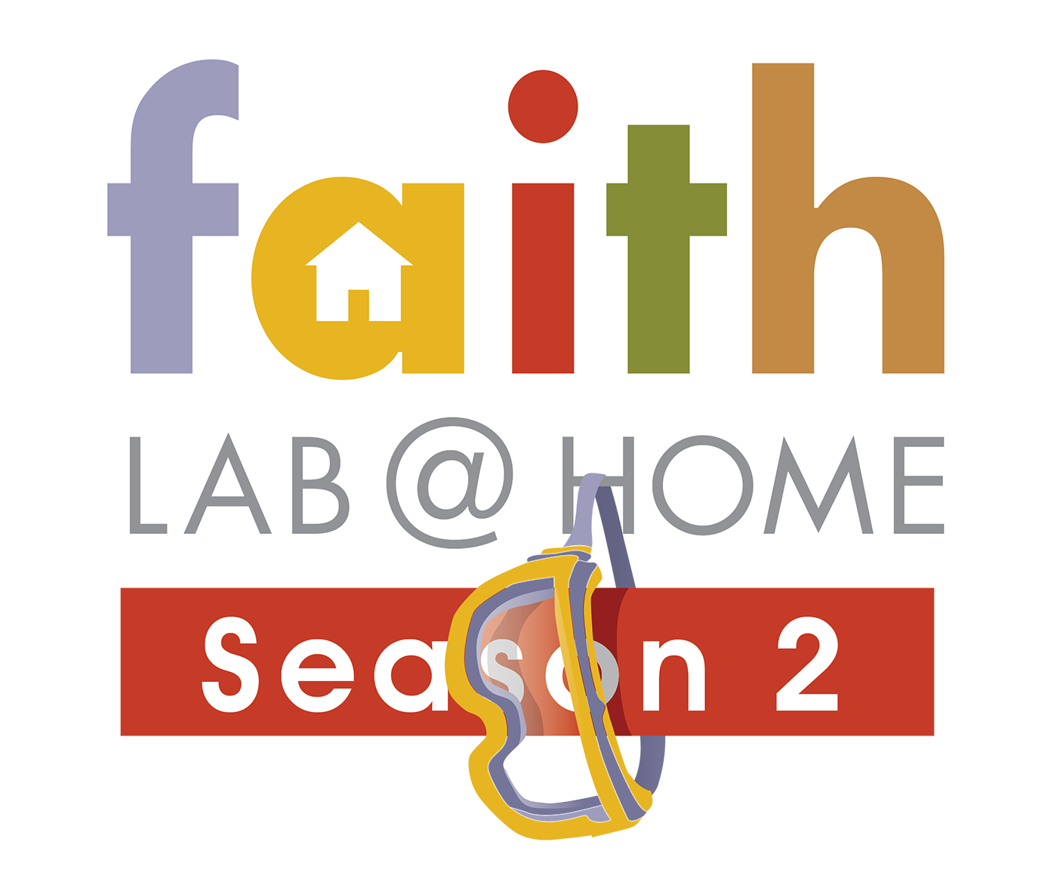

Daily Challenges for Social Media Engagement

Create big wins with your families through daily social media challenges. Create a list of families and tally family points as families post pictures, videos and more to your church social media page. Be creative! Make it memorable!

Memory Verse Challenges:
  - 5 daily memory verses
  - Provide points for video postings
  - Bonus points for parent memory verse participation

Family Pictures and Crazy Days
  - Crazy hair day
  - Family science outfits
  - Family pictures in front of the computer
  - Unique science themed dinner or snack

Some churches created their own social media challenge when they hosted Faith Lab @ Home – Season One using a BINGO card format.
- Comment to check in on each of the daily FB posts to receive a point.
- Let’s see your family spirit! Create a science-themed family photo showing your family completing Faith Lab @ Home Season Two.
- Crazy hair day – submit a picture!
- Create a family skit based on one of the daily verses and post the video here.
- Post memory verse challenge videos – extra points given for adults who memorize the verses with the kids!
- Record your family doing a lip synch or dance party to your favorite scripture song from the week.
- Make and enjoy a science-themed snack together. Post a recipe or photo to earn a point.
- Post a photo of your family’s catapult science project.

